Power BI Template to use Ally’s API for Reporting Tools
V 1.0

This guide provides step by step instructions to set up the Power BI template with the Ally API for reporting tools.

Important Disclaimer
- Please note that in order to access and visualize the data using this template file with the corresponding file extension (PBIX), you require a valid license for the associated software along with a compatible desktop application. Failure to obtain the appropriate license may result in restricted access to this application. Anthology is not responsible for any issues related to third party software licensing, including installation and maintenance.
- The data displayed in this application reflects the information available in Ally. The tool itself does not make any alterations. It is crucial that you verify the accuracy of the data before making any business decisions based solely on the projections provided in the developed template. Relying exclusively on this data may lead to inaccurate conclusions.

Contents
Power BI Template to use Ally’s API for Reporting Tools 1
Important Disclaimer 1
Template configuration 3
Configuration steps 3
Review your data 6

Template configuration
Before you start using the template make sure that you have the requisites mentioned in Integrate Ally’s API with an External Reporting Tool.
To integrate Ally's API with your preferred reporting tool you will need the following:
- An external reporting tool such as Power BI, Tableau, Microsoft Excel, or SAP Analytics, among others
- Access to Ally's Institutional Report (Admin only)
- Authorization API token (available in the Institutional Report)
- Endpoint's URL (available on this help page)
- Your Ally Client ID (contact our Support team if you do not have this ID)
- Keep in mind that you will need to switch between this help page, the Institutional Report, and the external reporting tool to successfully set up everything.

Configuration steps

- Open the Ally API template.pbix file in Power BI desktop.
- Select the data option on the left-hand side panel.
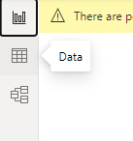
- Select the three dot menu for the Issues or Overall tables.
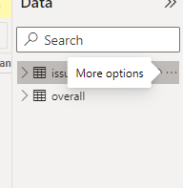
- Select Edit query
- Select the OverallURL and edit the current value
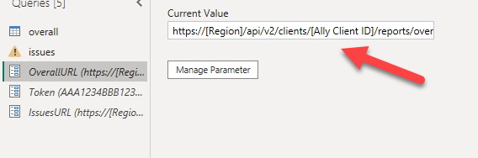

Replace [Ally Client ID] with your unique Ally ID.
If you do not have this ID, please contact our Support team. Remember that the is the Ally client ID, not the LMS ID.
Replace [Region] depending on the region where the Ally environment of your institution is hosted:
US data center: prod.ally.ac
Canadian data center: prod-ca-central-1.ally.ac
European data center: prod-eu-central-1.ally.ac
Singapore data center: prod-ap-southeast-1.ally.ac
Australian data center: prod-ap-southeast-2.ally.ac

- Repeat previous step with the IssuesURL and edit the current value replacing [Ally Client ID] and [Region] .
- Select Token and edit the Current value with the token obtained from the Institutional Report
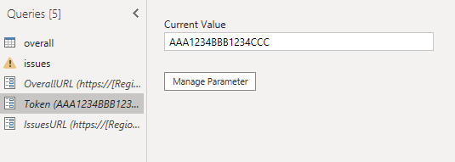
- Select Close & Apply
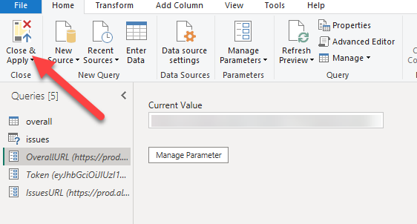
- Data will be requested
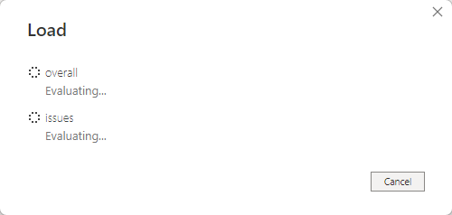
- If you do not see data immediately, wait for some minutes, select the three-dot menu on the right hand side and select refresh.
- Select the Report option, and you will see the report updated.
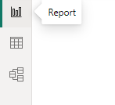

Review your data
If you want to review that your data corresponds to the correct environment, you can access your institutional report and download the CSV exports:
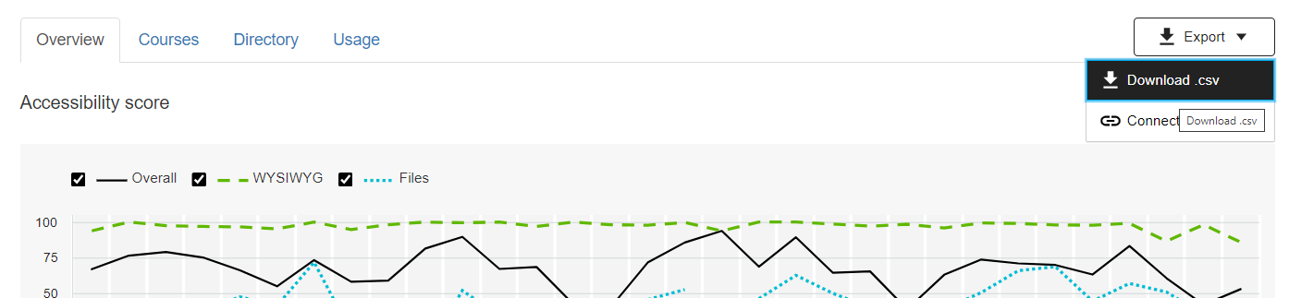
Select the Courses.csv file
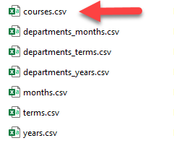
You can see that the data in the Power BI tables correspond to the export of the Ally data that belongs to your Ally institution report:
